Qatar University  College of Engineering  Dept. of Computer Science & Eng. | Software Engineering  CMPS 310 - Lab

Lab 8 Design Sequence Diagrams
Supporting tool - Visual Paradigm | 2 hours 30 minutes

Learning objectives
- Derive the messages of a design sequence diagram from the steps of a use case specification.
- Send each message to the responsible object, consistent with the operations and associations of the design class diagram.
- Model object creation, replies, self-calls, and alternative, optional or repeated behaviour with alt, opt and loop fragments.
- Revise the class diagram when a sequence diagram shows a missing operation or link.
Course learning outcomes: CLO 2 - Elicit, analyze, prioritize and document requirements for a software system. CLO 6 - Design, implement, test and present a software system in a group.

Design Sequence Diagram
A design sequence diagram shows how objects work together, in time order, to carry out one use case. It joins the two models you already have: the use case specification says what happens; the design class diagram says which object does it. In Visual Paradigm, create a UML Sequence Diagram, add the actor and lifelines, then draw messages from top to bottom and select an operation of the receiver's class for each.
Element | Notation | Meaning
Actor | 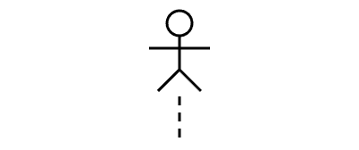 | The user or external system that starts or serves the interaction, as in the use case diagram.
Lifeline | 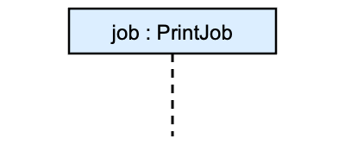 | One object taking part. Time runs down the page. Internal object lifelines use classes from the class diagram; actors and external systems remain outside the system boundary.
Synchronous message | 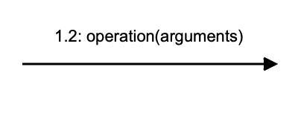 | A call. The receiver's class must have the operation.
Reply | 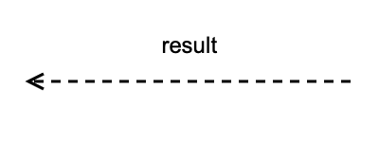 | Returns control and any result to the caller. Replies may be omitted when the return is clear; show important results in this lab.
Create message | 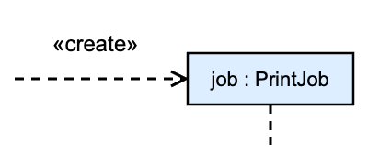 | Creates an object. Its box is drawn at the time of creation.
Self-call | 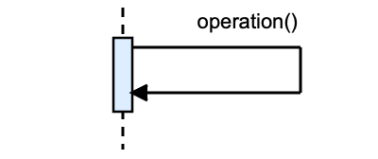 | A call to the object's own operation.
Activation |  | The period during which the object is carrying out a call.
Destruction |  | The object is discarded.
alt, opt, loop | 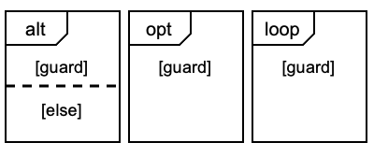 | Alternative branches, an optional part, or a repeated part. One alt operand runs; guards must not overlap.
Numbering | 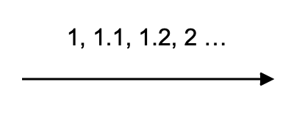 | Use message numbering or use-case step references consistently. The examples use both conventions; UML does not require numbering.

Five checks for every message
- Source. Follow the use-case steps. Actor requests go to the use-case controller; each system response becomes one or more messages.
- Receiver. Send each message to the object responsible for the action.
- Operation. Match the receiver’s operation name and parameters. Creation calls a constructor; external calls use the agreed interface.
- Link. The sender needs an association, parameter, or reference to an object it created or found.
- Flow. Show alternatives with Boolean guards and step references. Make clear which branches rejoin, repeat or end the use case.

Part A QU Print Shop — Worked examples
Figures 1 and 2 show a worked design using internal controllers, stored jobsLab 6 specifications and domain objects. The table records the refinements to the Lab 7 class model.
Class refinement | Operations and access
SubmitJobController | submitJob(user, doc, options): boolean. Uses PASGateway and PrintJobRepository; creates and retains the new PrintJob.
CollectionController | recordCollection(user, job): void; issueReceipt(job): CollectionReceipt. Receives the job reference and uses PrintJobRepository.
PrintJobRepository | save(job): void records or updates a job; retains the stored PrintJob objects.
PrintJob and CollectionReceipt | Keep calculateCost() and markCollected(). Add queue(): void and attachReceipt(receipt): void to PrintJob. Constructors receive the data shown in the figures.
- Submit job: the controller creates a temporary PrintJob, asks it for its cost, and checks credit through PASGateway (UC006). Sufficient credit queues and saves the job; insufficient credit discards it and returns false.
- Collection: the controller marks the supplied printed job as collected and saves it. At “collection recorded”, an optional request creates and attaches a receipt, then saves the job again.
- Why these receivers? Controllers coordinate requests; PrintJob owns its cost, status and receipt; the repository stores jobs; PASGateway communicates with PAS.

A.1 Submit a print job
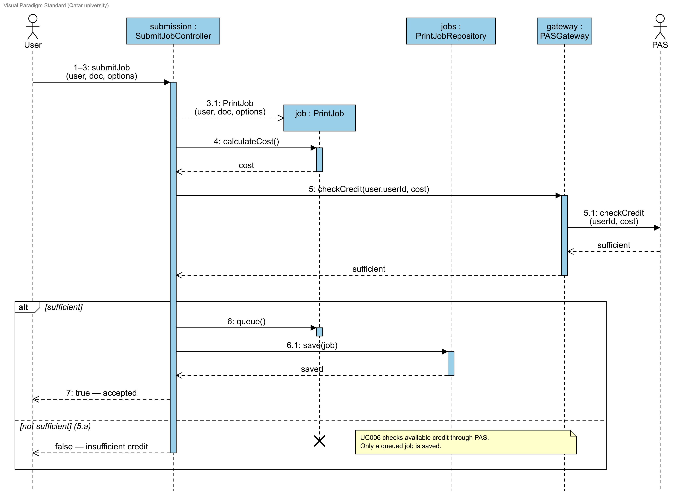
Figure 1 QU Print Shop: UC001 Submit print job

A.2 Optional receipt
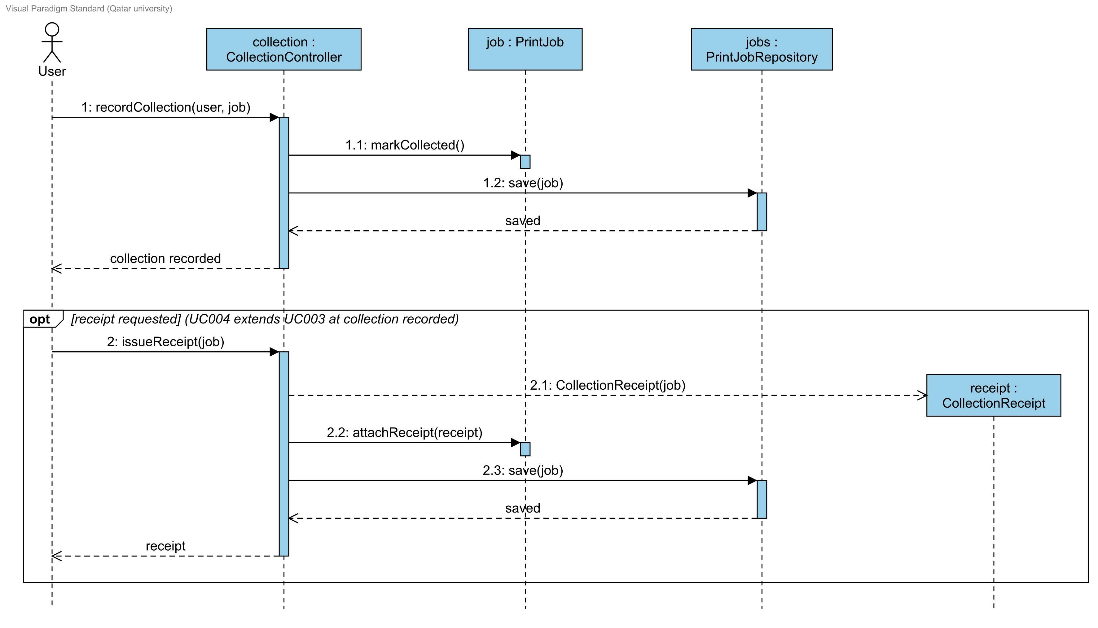
Figure 2 QU Print Shop: UC003 Collect printed document
The opt fragment implements UC004 at the “collection recorded” extension point. Collection succeeds even when no receipt is requested.
Design detail: the two controllers divide the Lab 7 PrintShop responsibilities. Submit input steps 1–3 are combined in one form request. The collection example assumes the supplied job is already printed.

Part B All Phones Shop - Individual sequence diagrams
Review the Part B class diagram (Figure 3) and the Register client worked example (Figure 4) with your instructor (10 minutes). The two task specifications are included at the end of this handout.
For UC003 List item for sale and UC006 Place bid, draw your own design sequence diagrams and prepare lab08-solution.docx using the instructions below.

Part B design class diagram
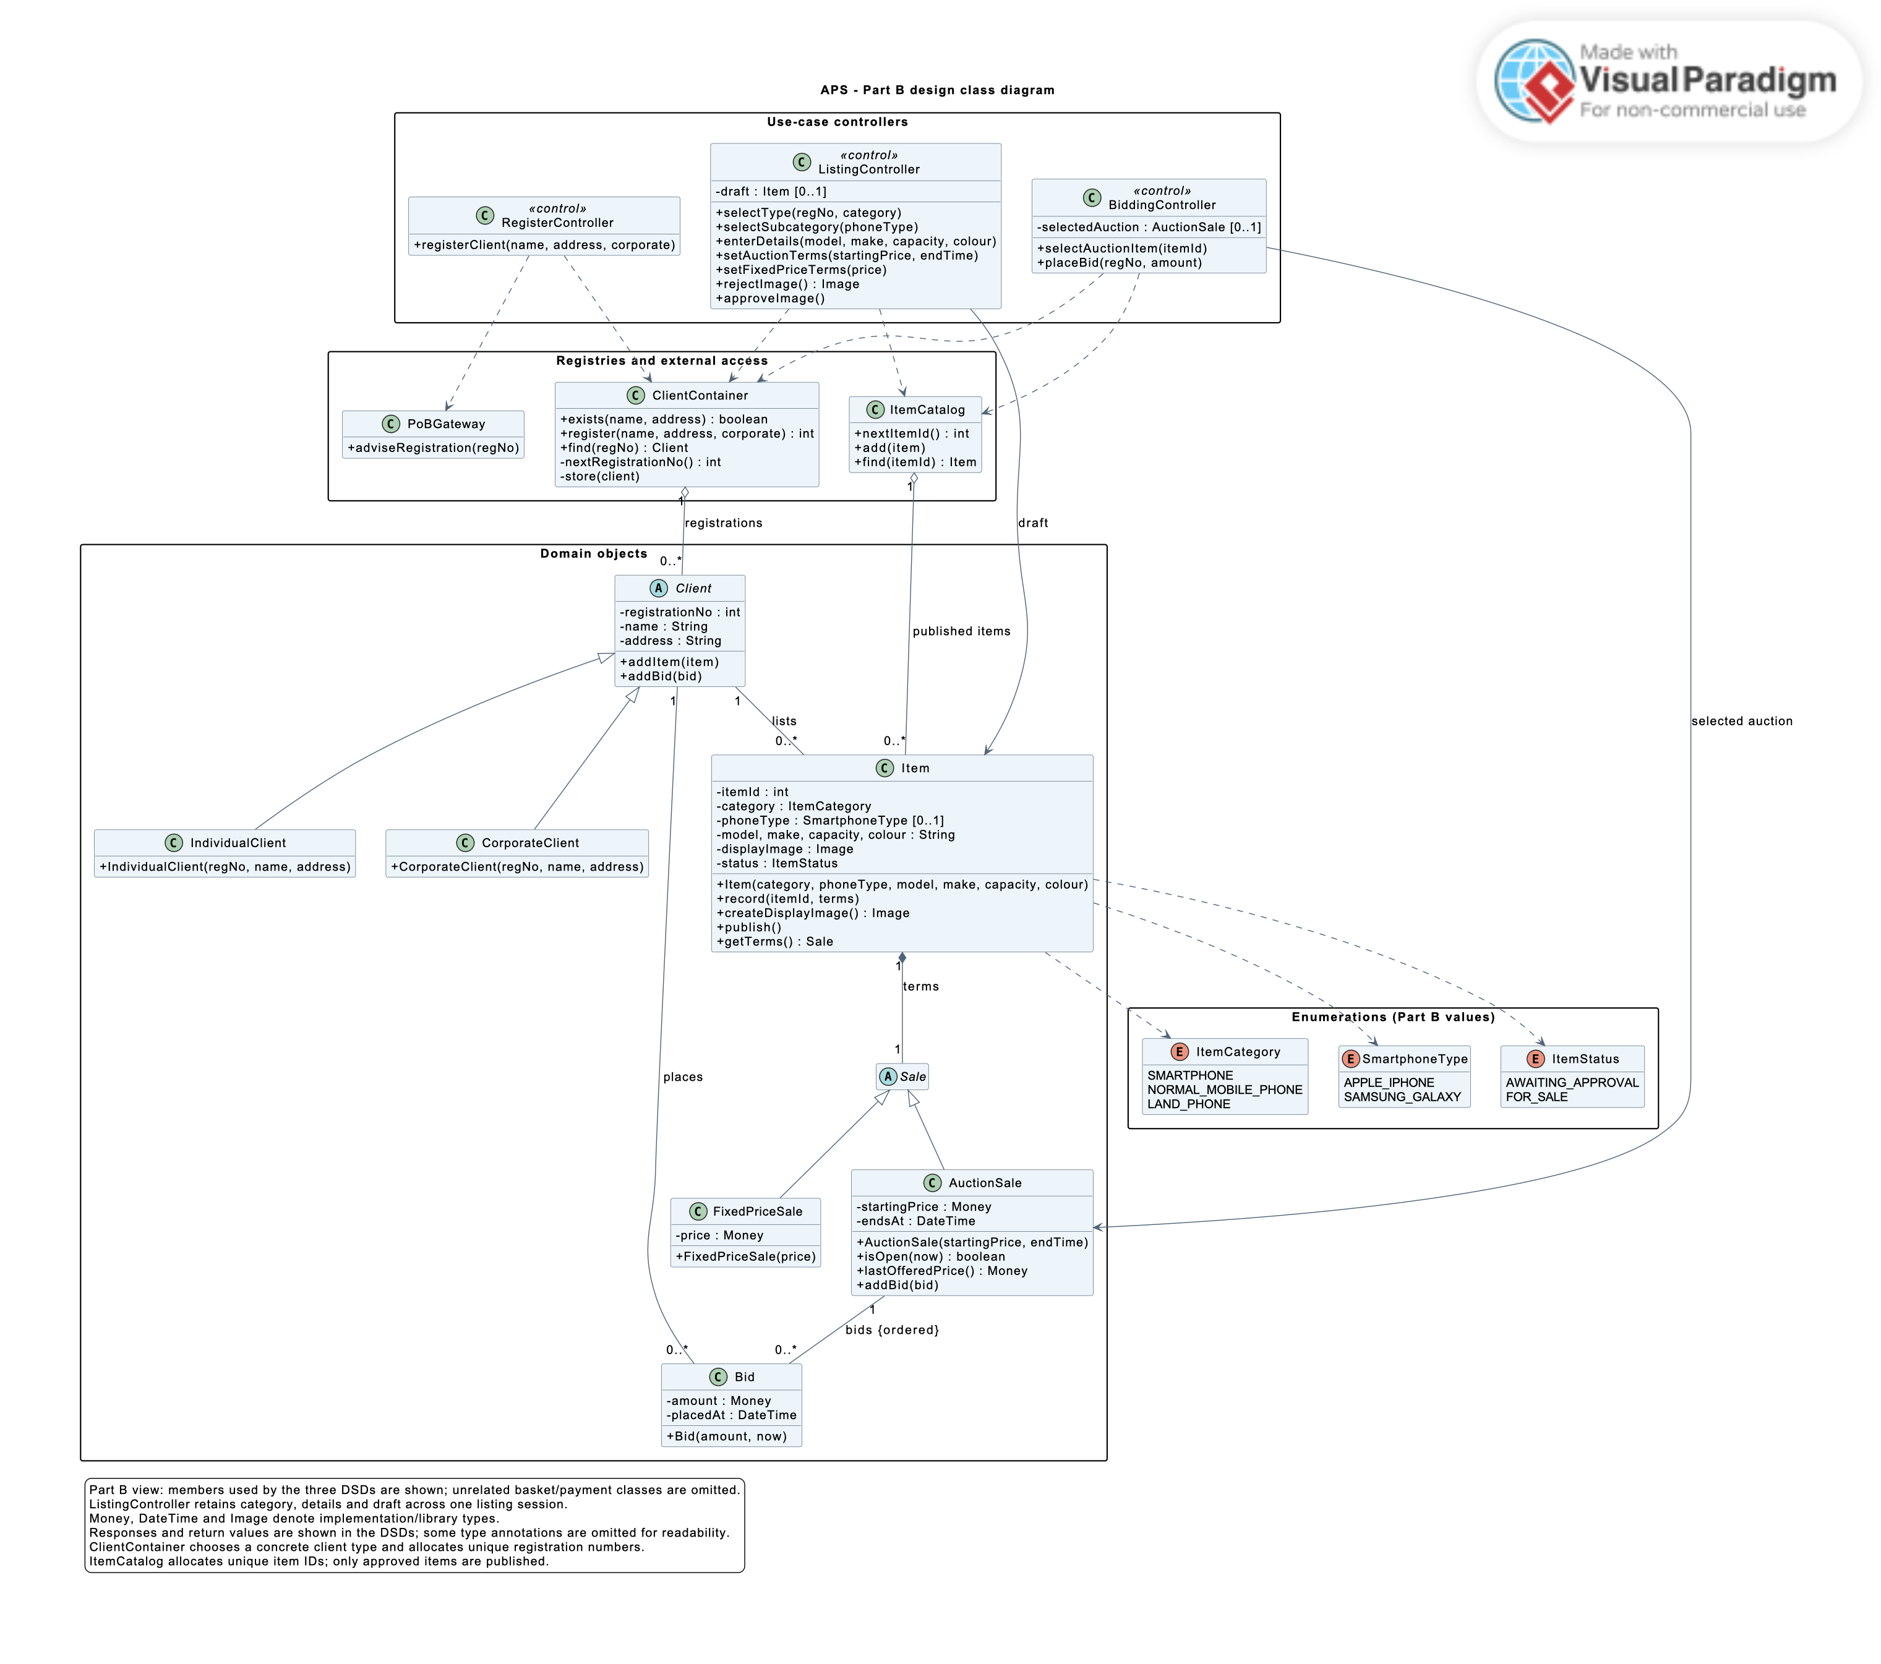
Figure 3 APS design class diagram — Part B view
Use this class model as the starting point for Part B. ListingController retains the draft item, and BiddingController retains the selected auction between requests.
Class | Operations used by the DSDs (parameters appear in the diagrams)
RegisterController | registerClient
ListingController | selectType, selectSubcategory, enterDetails, setAuctionTerms, setFixedPriceTerms, rejectImage, approveImage
BiddingController | selectAuctionItem, placeBid
ClientContainer / ItemCatalog | exists, register, find, nextRegistrationNo, store / nextItemId, add, find
Client / Item | addItem, addBid / record, createDisplayImage, publish, getTerms
AuctionSale / PoBGateway | isOpen, lastOfferedPrice, addBid / adviseRegistration

Worked example: Register client (UC001)
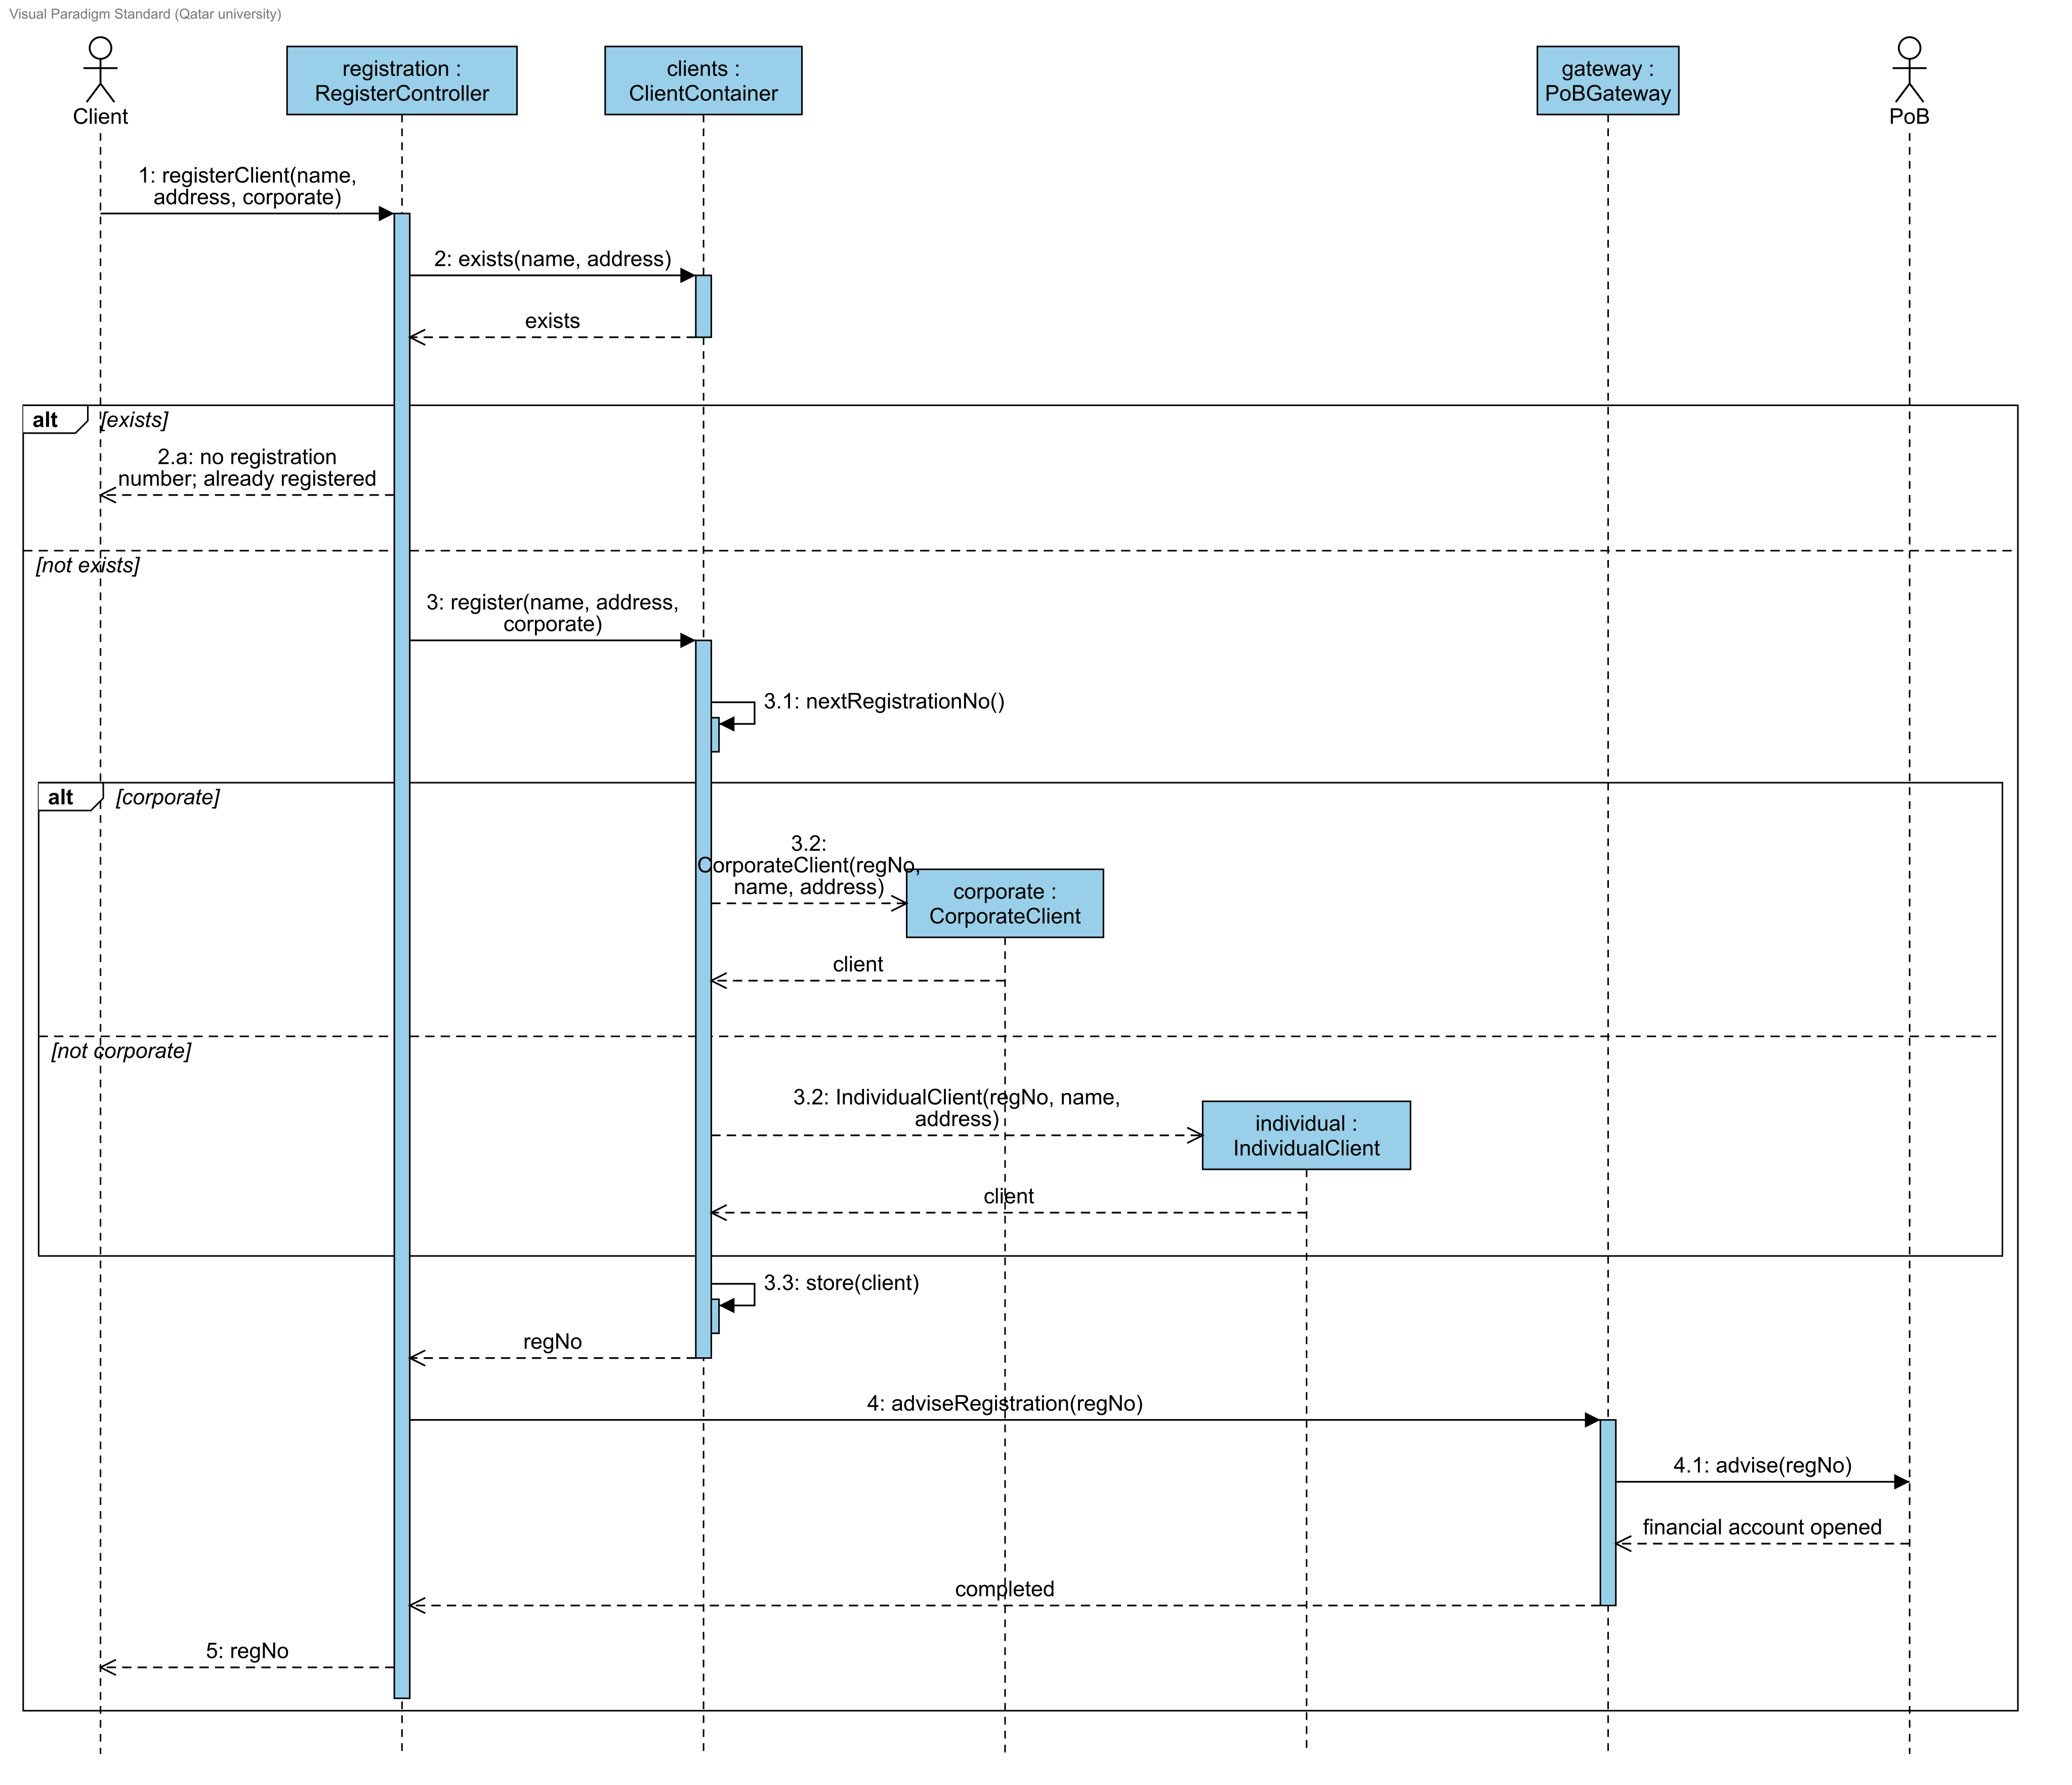
Figure 4 APS: UC001 Register client — design sequence diagram
A client provides a name and address. APS rejects an existing registration; otherwise, it assigns a unique number, notifies PoB to open the financial account, and returns the number. RegisterController coordinates these objects. The corporate flag is a design input for selecting the client subclass.

Task 1: List item for sale (UC003) - 40 minutes
- Create Table 1 for UC003 with four columns: Specification step, Message, Receiver, and Operation in the class diagram. Add one row per step and more rows where needed.
- Draw the diagram in Visual Paradigm. Show how alternative flows 1.a, 3.a and 7.a are handled, the re-creation of the display image, and the item's inclusion in the catalog.

Task 2: Place bid (UC006) - 40 minutes
- Create Table 2 for UC006 using the same four columns.
- Draw the diagram. Show the creation of the Bid, its recording in the client's registration, and alternative flows 2.a, 4.a and 4.b, including where the use case resumes or ends.
APS does not specify the first-bid rule. State your assumption; for example, compare the first bid with the starting price.

Review and update the class diagram - 15 minutes
Exchange diagrams with a classmate and apply the five checks to every message. Record one problem found and the change you made. Record required class changes and their source messages; include the updated class view in your document and .vpp, or state 'No changes required'.

Submission requirements
10 minutes. Open the CMPS310 GitHub repositories and select your own repository. Submit these two files inside a folder named Lab 8 Sequence Diagrams, using the individual repository workflow from Lab 4. Part A is not submitted. Commit and push both files, then check that they open from your repository.
File | Required contents
lab08-solution.docx | Name and student ID; Tables 1 and 2; readable images of both sequence diagrams; the review record; class diagram changes; any stated assumptions.
aps-sequence-diagrams.vpp | Editable Visual Paradigm project containing both sequence diagrams.

Assessment criteria (10 points)
Criterion | Points
Messages trace the specification: every actor action and system response is covered, in order, with step references | 3
Messages are consistent with the class diagram: correct receivers, operations, arguments and links; the class diagram is updated where needed | 3
Alternative flows, object creation and replies are modelled correctly using suitable fragments and guards, with clear continuation or termination | 2.5
Correct notation and numbering, readable diagrams, review record and complete submission | 1.5

Further reading: Visual Paradigm: What is Sequence Diagram?; OMG UML 2.5.1, Clause 17 Interactions

UC003 List item for sale specification
Use case ID: | UC003 List item for sale
Brief description | A registered client lists a phone for sale by auction or at a fixed price. APS records the item, prepares a display image for the seller’s approval and includes the approved item in the product catalog.
Primary actors | Client, acting as seller.
Secondary (supporting) actors | None.
Trigger | The client chooses to sell an item.
Preconditions | Login has been checked outside APS. The client has a registration.
Postconditions | The item is recorded with its ID, details, sale type and terms, attached to the client’s registration, and displayed in the product catalog with the approved image.
Main Success Scenario
Actor Action | System Response
1. The client selects the type of item: smartphone, normal mobile phone or land phone (see 1.a).
2. The client provides the model, make, capacity and colour.
3. The client selects sale by auction and gives the starting price and the auction end time (see 3.a). | 4. APS assigns an ID to the item.  5. APS records the item information and sale terms and attaches them to the client’s registration.  6. APS creates a display image from the item description and asks the client to approve it.
7. The client approves the display image (see 7.a). | 8. APS includes the item in the product catalog and displays it for sale.
Alternative flows:
1.a. Smartphone: the client also selects the sub-category, Apple iPhone or Samsung Galaxy. The use case resumes at step 2.
3.a. Fixed-price sale: the client selects fixed-price sale and gives the price. The use case resumes at step 4.
7.a. Image not approved: APS re-creates the display image and asks the client again. The use case resumes at step 7.

UC006 Place bid specification
Use case ID: | UC006 Place bid
Brief description | A registered client offers a price for an item on auction. APS accepts the bid if the auction is still open and the bid is greater than the last offered bid, and records it in the client’s registration.
Primary actors | Client, acting as buyer.
Secondary (supporting) actors | None.
Trigger | The client selects an item on auction to bid on.
Preconditions | Login has been checked outside APS. The client has a registration. The item is displayed in the catalog for auction.
Postconditions | The bid is recorded in the client’s registration and is the last offered bid for the item.
Main Success Scenario
Actor Action | System Response
1. The client selects an item on auction. | 2. APS checks that the auction end time has not passed and shows the last offered bid (see 2.a).
3. The client submits a bid price. | 4. APS checks that the auction end time has not passed and that the bid is greater than the last offered bid (see 4.a and 4.b).  5. APS records the bid in the client’s registration as the last offered bid.  6. APS confirms the accepted bid to the client.
Alternative flows:
2.a. Auction ended: APS informs the client that the auction has ended. No bid is recorded and the use case ends.
4.a. Auction ended before the bid was submitted: as 2.a.
4.b. Bid not greater than the last offered bid: APS rejects the bid and informs the client. The use case resumes at step 3.

